**NOTICE TO PATIENTS**

**PATIENT SURVEY FEEDBACK FOR 2017/18 FROM HEALTHWATCH**

**THIS IS WHAT OUR PATIENTS TOLD US:**

**SATISFACTION OVERALL**

Nine out of the ten patients surveyed were satisfied with the surgery and seven out of eight patients said they would recommend the surgery.



Our visit rated the surgery as good in providing an environment for patients, giving it a score of 8.2 out of 10.





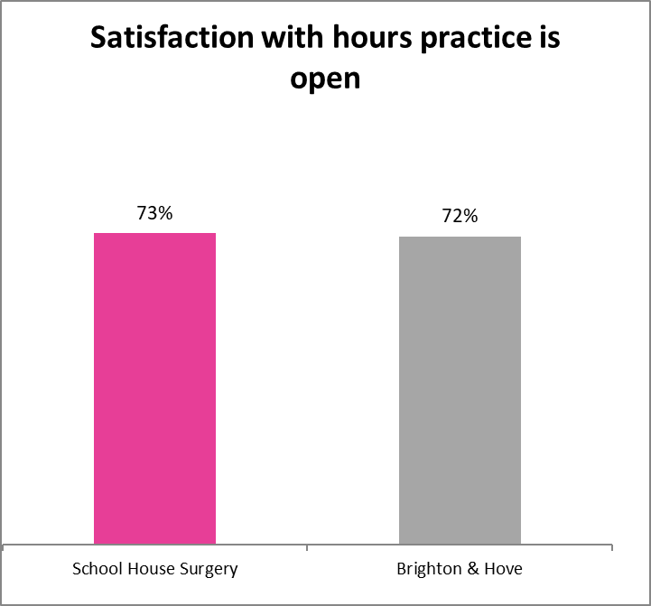



**Booking appointments**

The surgery offered all online facilities to book an appointment and order prescriptions.





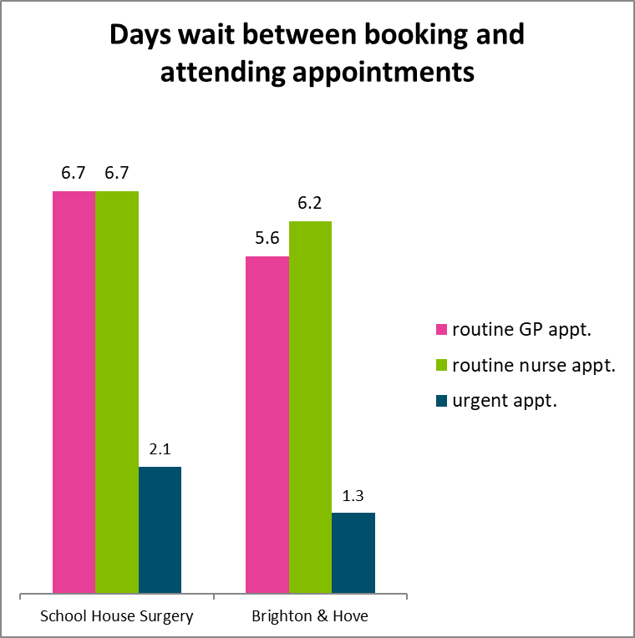



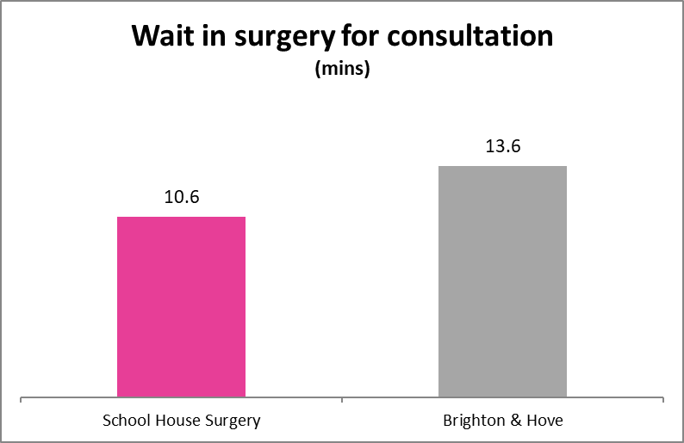



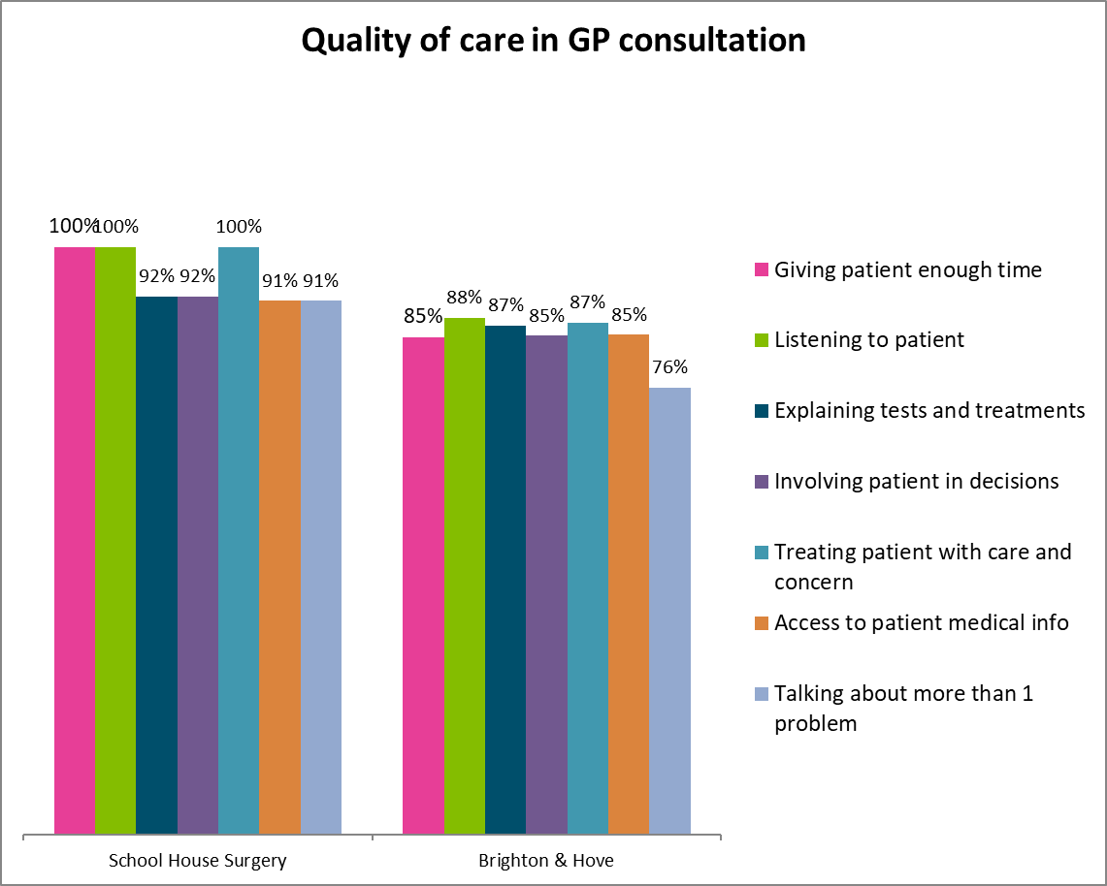



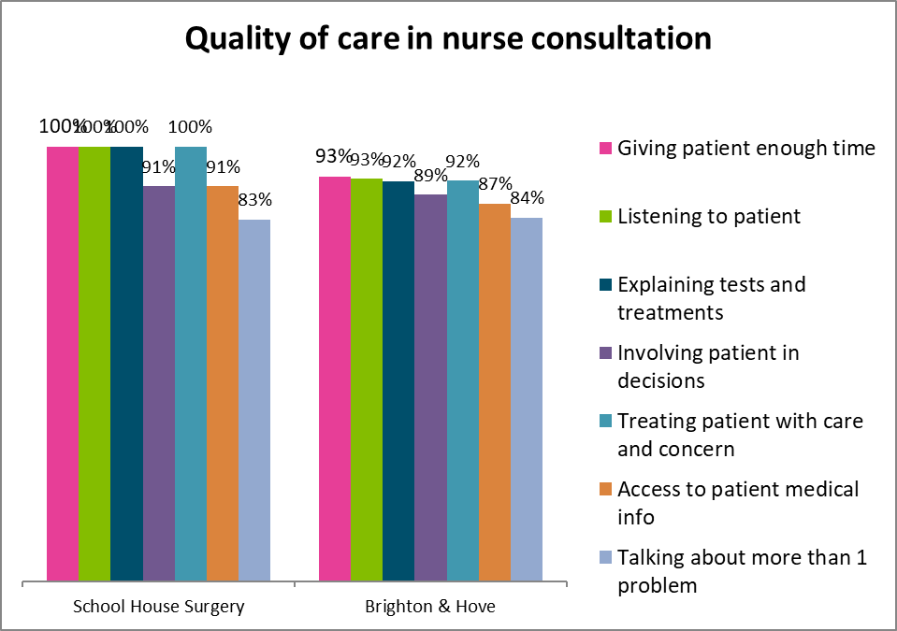



**Environment**

**ENVIRONMENT**

Our visit rated the surgery as good in providing an environment for patients, giving it a score of 8.2 out of 10.

Our visit observed that staff were friendly and welcoming and that there was a good atmosphere in the waiting room. Water was available from the receptionist and there was hand gel in the lobby. The toilets were well sign-posted. Feedback forms were available on the counter and clearly marked.

The information displayed was mostly comprehensive and well presented. Our volunteers noted that while safeguarding and ‘end of life care’ was mentioned in a subheading, there did not appear to be any information available on these subjects. Our volunteers also mentioned a minor point that the sign regarding switching mobile phones off could be clearer.

**PRACTICE ACTION/RESPONSE**

Patients will now observe we have added a new poster to the door to explain that mobiles are acceptable but in respect of other patients & staff they should be switched off or in silent.

Safeguarding/end of life information now displays some further information for patient care and support.





**PATIENT COMMENTS**

**Very helpful and they have always looked after me**

**All the staff there are great**